1

0.7 The beginner’s boogie
[Nick Head and Shoulders]

A great little tune to get you started.
Blues based instrumental
Demo end result
Explain backtrack

[Cut to Nick plus Guitar]
[Cue backing track]
Demo against fast backing track

In this lesson ---use this tune to show
how to play single note lead lines
-from Tab.

[Cut to 16to9_tabbegboogie.jpg]

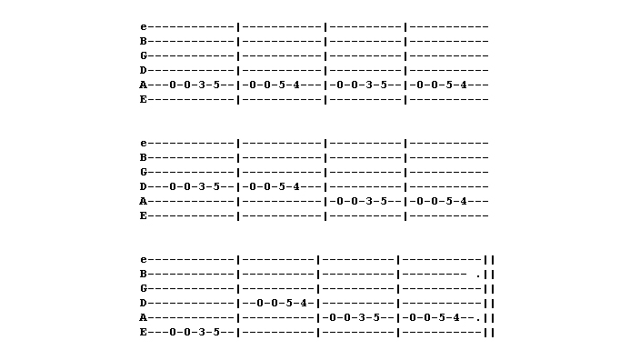

2
First off - we are just going to look at the first bar

[Cut to 16to9_tabbegboogie1.jpg]

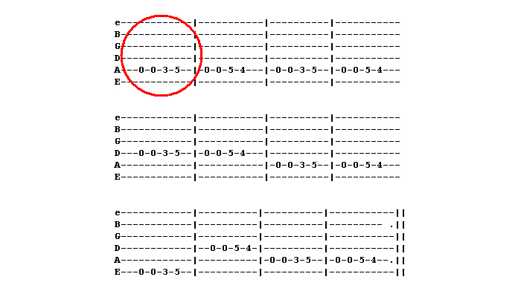

[Cut to 16to9_tabbegboogie2.jpg]

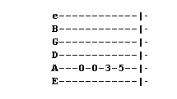

[Cut to Nick’s Left Hand and Superimpose 16to9_tabbegboogie2.jpg in top RH corner]

3
Line up hand at fret 3
Assign 1 finger/fret
Play opening lick
Start slow and build speed gradually
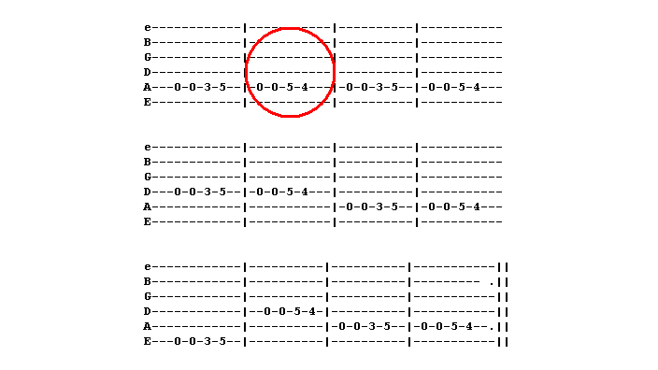
Once you’ve got that move to the next bar

[Cut to 16to9_tabbegboogie3.jpg]

[Cut to 16to9_tabbegboogie4.jpg]

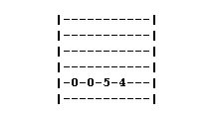
[Cut to Nick’s Left Hand and Superimpose 16to9_tabbegboogie4.jpg in top RH corner]

4
Open, Open Five Four
Demo

Again, repeat the phrase as many times as necessary to make it easy

First and second phrases together

Superimpose 16to9_tabbegboogie5.jpg in top RH corner]
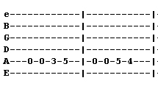
Demo

Then look at next two bars
We see repeat

Cut to 16to9_tabbegboogie6.jpg]
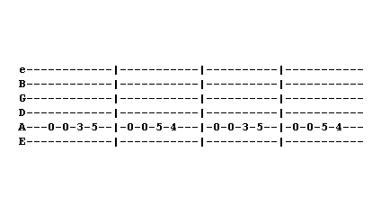

5
[Cut to Nick’s Left Hand and Superimpose 16to9_tabbegboogie6.jpg in top RH corner]

Music often repeats patterns
Play line few times

[Cut back to Nick Head and shoulders]

Now the first two bars of the second line.

[Cut to 16to9_tabbegboogie7.jpg]
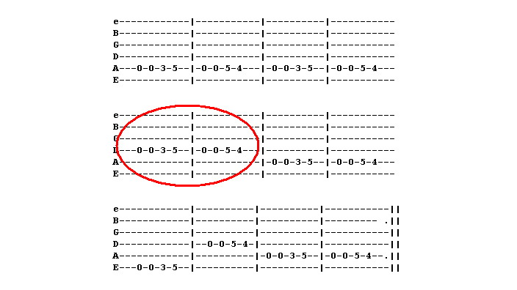

[Cut to 16to9_tabbegboogie8.jpg]

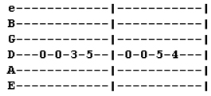
6
[Cut to Nick’s Left Hand and Superimpose 16to9_tabbegboogie8.jpg in top RH corner]

We can see same pattern but on D string

Then look at next two bars

[Cut to 16to9_tabbegboogie9.jpg]
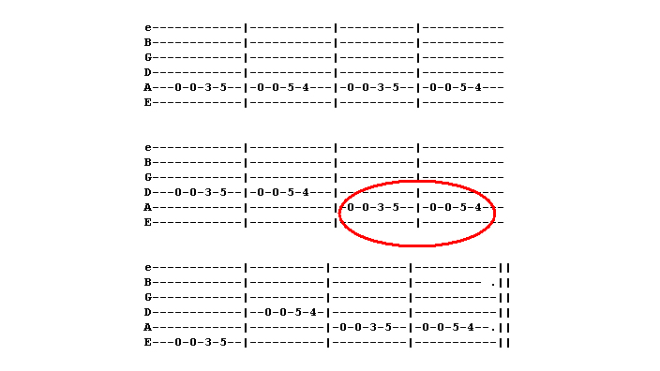

[Cut to 16to9_tabbegboogie10.jpg]
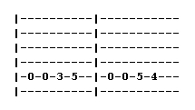
[Cut to Nick’s Left Hand and Superimpose 16to9_tabbegboogie10.jpg in top RH corner]
7
See same pattern as we started out with
Demo

[Cut to Nick’s Head and Shoulders]

I’m going to play first two lines
If easy then feel free to carry straight on
Otherwise Pause spend time repeating

[Cut to 16to9_tabbegboogie11.jpg]
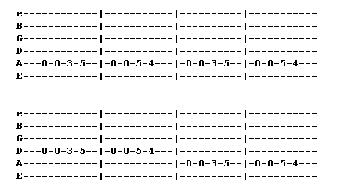
[Sound track will continue behind this image.]

[Cut to Nick’s Head and Shoulders]

Now let’s do last line
Things jump around a bit here
Look at bar 9

8
[Cut to 16to9_tabbegboogie12.jpg]
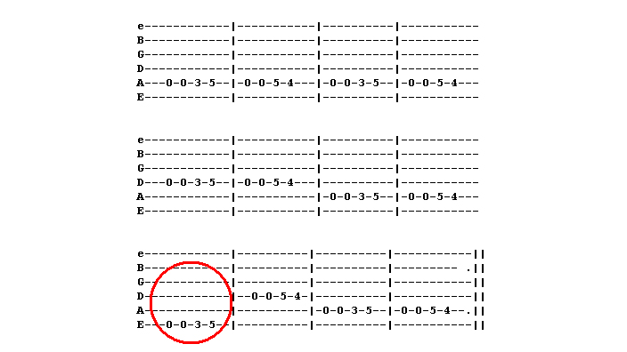

[Cut to 16to9_tabbegboogie13.jpg]

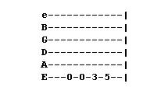
[Cut to Nick’s Left Hand and Superimpose 16to9_tabbegboogie13.jpg in top RH corner]

Same pattern as opening phrase
But on 6th string
Demo

Then jump to D string for bar 10

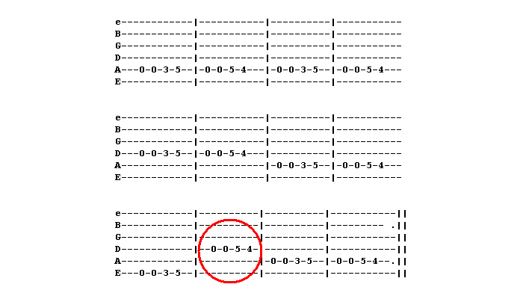
[Cut to 16to9_tabbegboogie14.jpg]
9
[Cut to 16to9_tabbegboogie15.jpg]
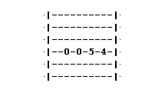

[Cut to Nick’s Left Hand and Superimpose 16to9_tabbegboogie15.jpg in top RH corner]

Notice its second phrase
Demo

Practice repeating bars 9 and 10
Most tricky

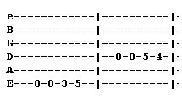
[Superimpose 16to9_tabbegboogie18.jpg in top RH corner]

Demo

Then finally back to the last two bars
[Cut to 16to9_tabbegboogie16.jpg]
10
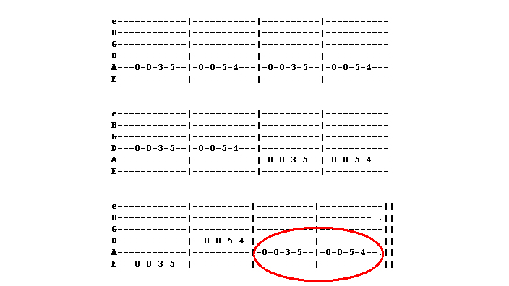
Which are the same as the first two
[Cut to 16to9_tabbegboogie17.jpg]
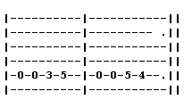

Demo

[Cut to Nick Head and Shoulders]

11

Once have this well practised you can play it against backing tracks accessed from the toolbar to the right of the video screen. You’ll find four tracks. Complete recordings slow and fast and Backing tracks slow and fast.

You can also access the tab in printable form by clicking on the Tab button on the toolbar.

For now I’ll leave you with the tab for the whole tune up on the screen

Enjoy!

[Cut to 16to9_tabbegboogie.jpg]

================================================================

