1
3.2 Classic Guitar Intros and Riffs – Come as you Are by Nirvana

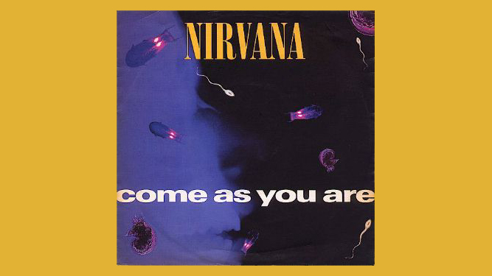
[Open with 16to9_IntroComeAsYouAre.jpg]
[Attach sound file: SGT_IntroComeAsYouAre.wav]

[Cut to Head and Shoulders]
There’s a nice simple but effective riff that has become a classic from the early nineties when the song was released.

A couple of points about the original recording.

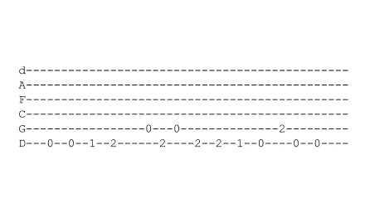
The guitar has been down-tuned a whole tone so you’ll see on our tab that instead of the normal EADGBE notes at the start of the tab we have DGCFAD.

[Cut to 16to9_TabIntroComeAsYouAre.jpg]
2
Now I know people have different feelings about wanting to down-tune the guitar and actually it’s only really essential to do this if you want to play along to the original recording and sound in tune with it.

[Cut to Head and Shoulders]
Towards the end of this lesson I will show you how to down-tune, but for now, we’ll assume your guitar is in standard tuning and we’ll go ahead and learn the Intro in E instead of D – I promise that most people hearing it won’t notice the difference!

Also Kurt Cobain uses a chorus pedal on the original to get that sort of underwater sound effect. Again this is something I know some of you are interested in, more than others, so I am going to save my advice about that until the end of the lesson and meanwhile we’ll carry on and learn the intro with a clean sound.

So let’s go:

3
[Cut to RIGHT hand with 16to9_TabIntroComeAsYouAre.jpg as PIP]

We start with the 6th string played open twice
Demo

[Cut to LEFT hand with 16to9_TabIntroComeAsYouAre.jpg as PIP]

Then fret at frets one and two like this
Demo
Then we play two notes on the open 5th string bouncing off the note at the second fret on the bottom string like this:

The Right Hand is doing this
[Cut to RIGHT hand with 16to9_TabIntroComeAsYouAre.jpg as PIP]
Demo

While the Left Hand holds this note down on the 6th string at fret 2

4
[Cut to LEFT hand with 16to9_TabIntroComeAsYouAre.jpg as PIP]
Demo
So here’s what we’ve got so far:
Demo
And Here’s the Right hand view
[Cut to RIGHT hand with 16to9_TabIntroComeAsYouAre.jpg as PIP]
Demo

[Cut to LEFT hand with 16to9_TabIntroComeAsYouAre.jpg as PIP]
Next we sort of retrace our steps by going back to the note on the 2nd fret 6th string and hitting that twice before playing the same string at fret 1 and open

Demo
Finish the line with the note at fret 2 on the 5th string followed by two notes on the open 6th string:

Demo

So here’s that whole line left hand view:
Demo
And Here’s the Right hand view
5
[Cut to RIGHT hand with 16to9_TabIntroComeAsYouAre.jpg as PIP]
Demo
Now there is one final touch as you repeat the line you kind of bounce off the note at fret 2 on the 5th string before coming back into the main riff like this:

Demo

[Cut to Nick Plus Guitar]
This is shown on the printed tab which you can access from the toolbox to the side of the screen.

So go back over that as many times as needed to get it learnt then see if you can play through the whole intro with me a few times slowly after three : 1.. 2.. 3..
Demo

[Nick head and shoulders]
If you want to get the same sound as the recording you will need to add either chorus or flanger effect to your sound.
6
I’m using a programmable effects unit which allows me to mix chorus with a little bit of delay to get something like the right sound
Demo

Finally if you want to down-tune to sound in tune with the record then you have two choices. If you just want to play this intro then all you need to do is re-tune the bottom two strings down a tone like this:

Demo
Using the 12 fret to double check if you like.

You can of course also use your own electronic tuner or the one we make available from the toolbox. Remember you’re tuning the low E down to D and the A down to G.

We can now sound pretty much the same as Kurt Cobain..
7
Cue SGT_IntroComeAsYouAre.Wav
Demo
If you’re playing the whole song tune the remaining four strings down as well. If tuning manually take the notes off the bottom two strings and tune the rest of the guitar in the normal way like this:
Demo
If using a tuner tune down not up and tune as follows:
[Cut to 16to9_DownTuneToD.jpg]
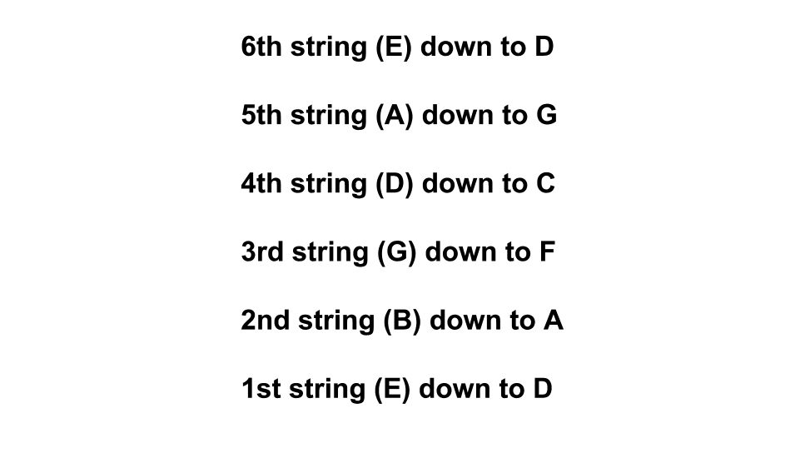
[Nick head and shoulders]
Ok that about wraps that one up – enjoy playing that. Why not pick another one of our classic Intros and Riffs to learn? Or let us know if you would like a lesson on your favourite riff or intro and its one we haven’t already covered. See you soon.

================================================================

