1
2.9 Guitar Gym – Pentatonic Backstitching

[Nick head and shoulders]
Once you have got your pentatonic scale drilled through five positions going smoothly then there are several other exercises based on that that will all have a great effect on your overall ability to solo.

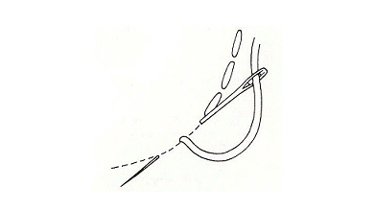
This exercise is called backstitching

[Cut to 16to9_backstitch.jpg]
For those of you who might have forgotten their basic needlework classes this is a stitch that goes kind of two steps forward, one step back.

Here’s how we apply this to practicing scales. You can apply this approach to any scale pattern but we are going to use the minor pentatonic in G as an example for this session.
2
[Cut to left hand]
Demo

[Cut to Nick Plus Guitar]
So let’s take a closer look at exactly how this works. Here’s the tab for this exercise:

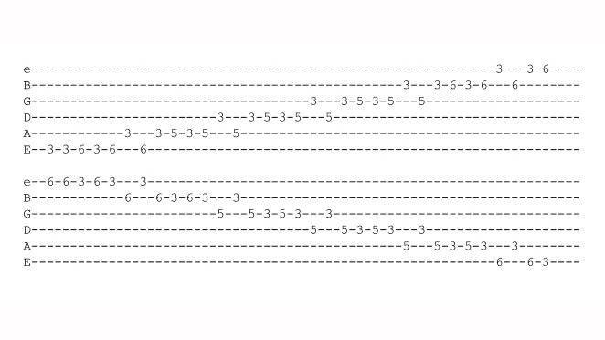
[Cut to 16to9_PentatonicBackstitch.jpg]

Looks like a lot of work so let’s just focus in on the first few notes:

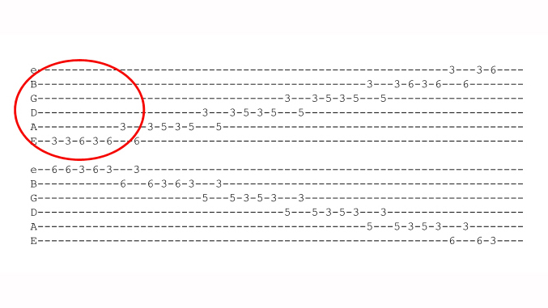
[Cut to 16to9_backstitch_2.jpg]
…And enlarge the tab…

[Cut to 16to9_backstitch_3.jpg]
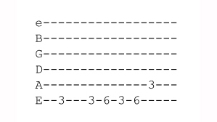
3
…Then slice into three separate phrases…
[Cut to 16to9_backstitch_4.jpg]
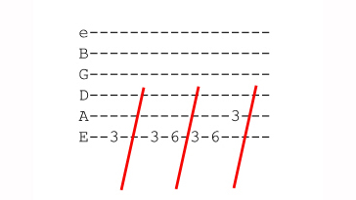

[Cut to left hand with 16to9_backstitch_4. jpg as PIP]

You can see that this is a G minor pentatonic first position scale pattern played first note one:
Demo
…then notes one and two
…then notes one two and three
Repeat Demo

[Cut to Nick Plus Guitar]
Practice that bit well for a minute or two and that will set you up well for the rest of the drill. Now the next bit is best seen as a three note pattern that’s repeated all the way up the scale…
4
[Cut to 16to9_backstitch_5.jpg]
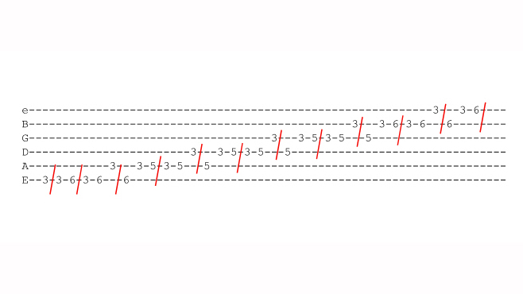
[Cut to left hand with 16to9_backstitch_5. jpg as PIP]

So after our three starting phrases…
Demo
We continue up the pattern going up two steps and back one – remember just like in needlework!
Demo
Keep going, repeating this idea all the way up to the top string.

Then we simply reverse the idea like this:
[Cut to 16to9_backstitch_6.jpg]
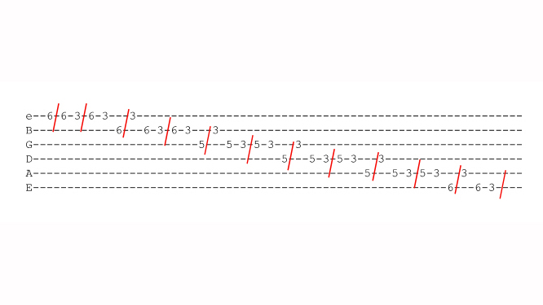
Again starting with just one note, then two then three…
5
[Cut to left hand with 16to9_backstitch_6. jpg as PIP]
Demo
Then into the main backstitching pattern…
Demo
…All the way back to the beginning..
Demo

[Cut to Head and Shoulders]
Before you have a go at that just check out the right hand action for this as well.
If you are using a pick you should start with two downstrokes then alternate from there..

[Cut to right hand]
Like this:
Demo

If you use fingers then you may have to experiment, but an alternating system is likely to flow the best..
Demo
IIM, IMI, MIM and P, Pi, PiP,iPi

6
[Cut to Head and Shoulders]

OK have a crack at learning that, be patient and persistent and if it’s not happening for you, break it down into three-note chunks as shown by the red markings.

We’ll post the full tab up here on screen for a moment, hit the pause button if you would like to practice that now. Then we’ll crack on with the full demo that includes giving the backstitching treatment to all five positions..
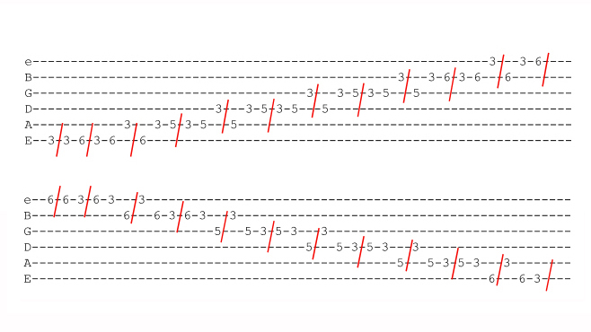
[Cut to 16to9_backstitch_7.jpg]

Pause five seconds then..

7
[Cut to Nick Plus Guitar]

Once you have mastered backstitching your way through the first position it is relatively easy to apply the same idea to the remaining positions.

For example the second position in G will look like this:

[Cut to left hand]
Demo
… and so on.

[Cut to Nick Plus Guitar]

A word about metronome settings for this exercise. It falls quite naturally into a 12/8 feel which we think of as four lots of three beats and count 1 and a 2 and a…

So set the metronome relatively slow and play three notes per beat.

Here’s a demo of the complete drill through five positions in the key of G at 80 bpm three notes per beat.

8
Join in if you have got the drill up to this speed. Don’t worry if not. Spend some time drilling it at a lower speed or without the metronome and then come back and test yourself against this demo at a later stage. So I’ll play out with this demo now and I’ll see you when you’re next in the Gym!

Demo 80bpm 3 npb

================================================================

