1
2.4 Speed developer
[Nick head and shoulders]
Intro:
Here is an exercise that follows right on from the easy warm-up exercise that we covered in the Guitar Gym Induction Lesson.

You can find tab for this in the toolbox, but for now it’s probably easier to pick it up just by watching …

[Cut to left hand]

Demo
Line up at fret 9
One finger per fret
Start by fingering 1 2 3 4
Then back – 3 2
- Get used to that for a minute
Then repeat across the strings like this:
Demo
When you reach the top string move position down one fret and reverse the fingering like this:
Demo
2
[Cut to Head and Shoulders]

Remember the rules about how to learn quickly and efficiently? Here’s a reminder

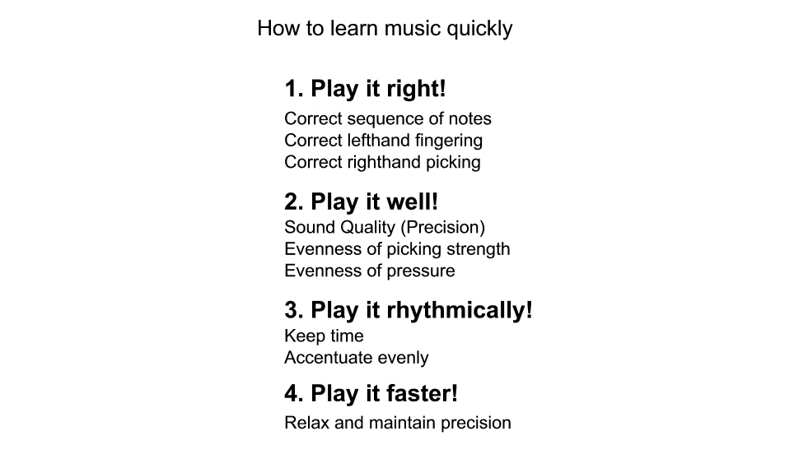
[Cut to 16to9_learnmusicquickly.jpg]

Under the first heading – play it right – we need to check the picking hand:

[Cut to right hand]
If using a pick try and alternate up/down
Demo
If using fingers choose a consistent approach from those outlined in the Induction lesson. I recommend leading with the middle finger on the way up and index finger on the way down:
Demo
[Cut to 16to9_learnmusicquickly.jpg]

Under the second heading play it well we need to check that our left hand fingers are placed just behind the frets.
3
[Cut to left hand]
Demo
The finger shape is curled so that the points of the fingers are on the strings.
Demo
Then listen as you play and get the quality of sound nice and consistent. Avoid sharp changes in dynamics..

[Cut to right hand]
Demo
And variations in clarity of sound caused by too much or too little pressure from the fretting hand…

[Cut to left hand]
Demo

[Cut to 16to9_learnmusicquickly.jpg]
Then play it rhythmically .. time to set the metronome. I’m going to use my mechanical one – you can use the online metronome from the tool box to right of video screen.

4
[Cut to Nick Plus Guitar]
So here’s the exercise played at 80bpm one note per beat. Once you are happy that you are playing it right and well then join me on this run through:

[Cut to Nick Plus Guitar plus metronome]
Demo
80bpm at 1npb

[Cut to 16to9_learnmusicquickly.jpg]
And finally – play it faster..

[Cut to Nick Plus Guitar]
First off you’ll do this by increasing the bpm on the metronome and continuing to play one note per beat.
Demo

But a word of warning once you get to the level where you are playing more than one note per beat. Because the exercise works most naturally in 6/8 time you will want to jump from one note per beat to three notes per beat…

5
So I would suggest working up to say 192 bpm at one note per beat:
Demo 192 bpm at 1npb

Then change the metronome to 63 bpm (roughly one third of the speed) and play three notes per beat:

Remember the trick about setting the speed on just the first note before you start.
Demo 63 bpm at 3npb

At higher speeds this may take a few seconds, but this is great training..
Demo 100 bpm at 3npb showing starting on first note

6
[Cut to Head and Shoulders]
OK so that’s the speed developer. Make that part of your warm-up routine and you’ll soon notice the benefits on all your playing.

Once you have got this one up and running nicely I recommend adding the Finger Separation exercise. That’s the next lesson in the Guitar Gym section.

See you then.

================================================================

