1
1.5 Texas style blues – vs.6

[Nick head and shoulders]
Intro:
Verse 6 – the last verse.
Tricky as it’s right up at the twelth fret

[Cut to Nick Plus Guitar]
Cue BTrack
Demo Texas Blues Verse 6

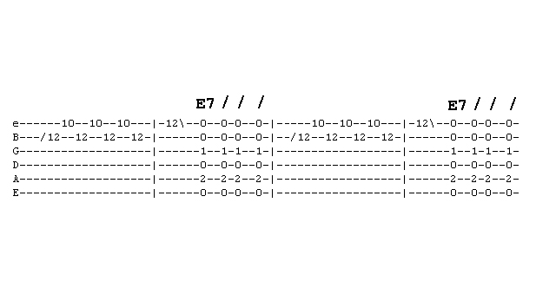
First look at tab for first phrase
[Cut to 16to9_tabTexBlues_19.jpg]
Although a slide is indicated by the slash symbol in front of the first note I
Suggest ignoring that to begin with.

[Cut to left hand with 16to9_tabTexBlues_19.jpg as PIP]
it will look after itself as a result of travelling from open chords
2
Demo
Likewise the slide after the last note.
Demo
So as you’re learning the lead just learn it straight like this
Demo
Notice we land on the E note fret 12
The next phrase is the same as always
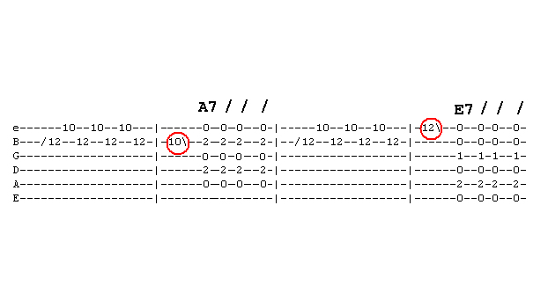
[Cut to 16to9_tabTexBlues_20.jpg]
For the next line the end note shifts to A at fret 10 on the B string
[Cut to left hand with 16to9_tabTexBlues_20.jpg as PIP]
Demo
Then back to E at fret 12 on the top string for the return to the E7 chord
Demo

3

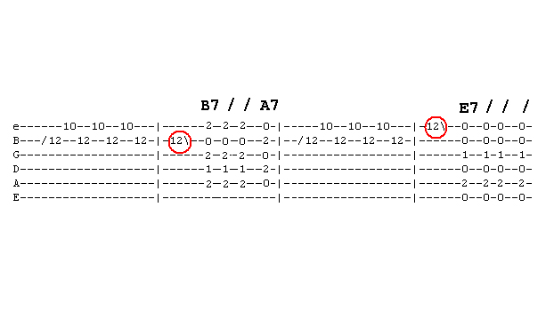
[Cut to 16to9_tabTexBlues_21.jpg]
The last line predictably lands on a B note
Before the B7 A7 change
[Cut to left hand with 16to9_tabTexBlues_21.jpg as PIP]

Demo
Before returning to the original phrase to take us back to the E

[Cut to Nick Plus Guitar]
If we remember that our notes at the twelfth fret are the same as the open strings we can locate our three end phrase notes to match the root notes of the chords then easy to remember phrases
Demo

4

The final touch is to put in the slides
Demo Aeroplane landing
Also Demo what not to do

Now we’re ready to play the whole verse
Demo with whole verse played faintly

Now you have learnt all six verses try putting it all together yourself
Here’s the backing track. I’ll play through with you on the first run through then leave you to it.
Cue Backing Track
Have fun with that and once you have got it down come back for the next lesson where we look at how to use the phrases from Texas Blues to play Improvised blues ================================================================

