1
1.1 Texas style blues – vs.2

[Nick head and shoulders]

Intro:
Verse 2 same chords different lead
Introduces bending technique
[Cut to Nick Plus Guitar]
Cue BTrack
Demo Texas Blues Verse 2

First look at tab for first phrase
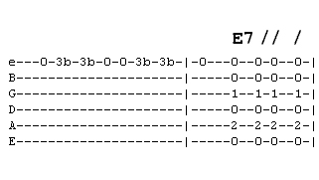
[Cut to 16to9_tabTexBlues_5.jpg]

See we are playing the whole phrase on the top E string.
Explain ‘b’ after the 3 means bend
[Cut to Left hand with16to9_tabTexBlues_5.jpg as PIP]

Demo bend

2
So here’s the whole phrase
Demo phrase
And as in verse one that is answered by the chords
Demo Chord call and response

You can see from the Tab that this is simply repeated to complete the first line
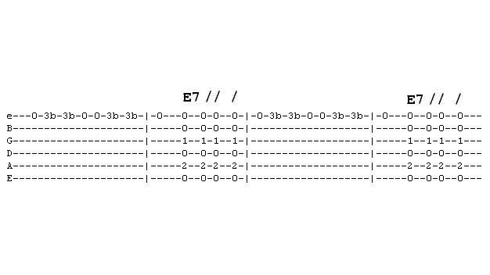
[Cut to 16to9_tabTexBlues_6.jpg]

[Cut to Nick plus guitar with 16to9_tabTexBlues_6.jpg as PIP]
Let’s play this together a few times
You play the lead I’ll play the chords
Demo
Repeat demo

If you need a bit more time pause and practice before moving on.

3
[Cut to 16to9_tabTexBlues_6.jpg]
...5 seconds or so…

[Cut to Nick Head and Shoulders]
The second line is nice and easy as it repeats the same lead
-blues often does that

[Cut to 16to9_tabTexBlues_7.jpg]
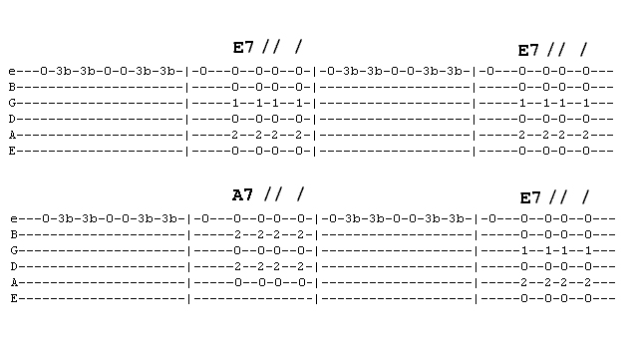
[Cut to Left hand on the guitar with 16to9_tabTexBlues_7.jpg as PIP]
Here’s how it sounds so far
Demo first two lines

[Cut to Nick plus guitar with 16to9_tabTexBlues_7.jpg as PIP]

4
Have a go playing along either just lead or chords as well
I’ll play faintly to help timing
Demo first two lines

Now to last line
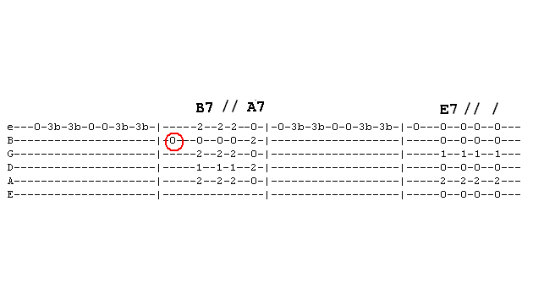
[Cut to 16to9_tabTexBlues_8.jpg]

Notice ‘B’ note only change
[Cut to Left hand with 16to9_tabTexBlues_8.jpg as PIP]

Demo difference
Remember this is where the chords jump
Demo B7 A7 change

Make it fit time wise even if you have to drop the first E note
Demo dropping E note
5
[Cut to head and shoulders]
Now ready to play right the way through you play/ I play faintly let’s go!
[Cut to Nick plus guitar]
Demo
And again
Repeat Demo

Now you have learnt first two verses try putting it all together yourself
Here’s the backing track. I’ll play through with you on the first run through then leave you to it.
Cue Backing Track

Remember any time you want to practice that you can access the backing track from the toolbox menu

Have fun with that and once you have got it down come back for the next lesson when I’ll show you how to play verse Texas Blues.
================================================================

